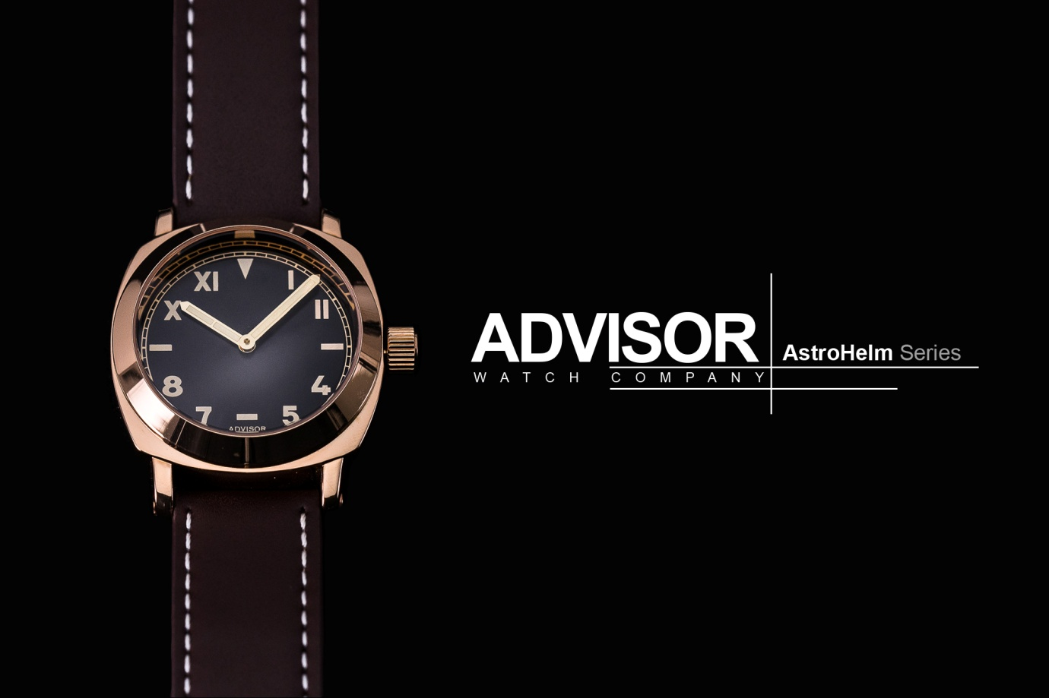

**ASTROHELM SERIES - TRIBUTE TO HISTORY**

31 July, 2017, the team from Advisor Watch Company (AWC) launched their second collection, AstroHelm on Kickstarter, a crowdfunding platform for start-up and aspiring brands.

Simplicity is the ultimate sophistication. Advisor **AstroHelm** series pay tribute to the heritage California dial design first appear in the 1930s. It is a watch dial that consists of half Roman and half Arabic numerals.

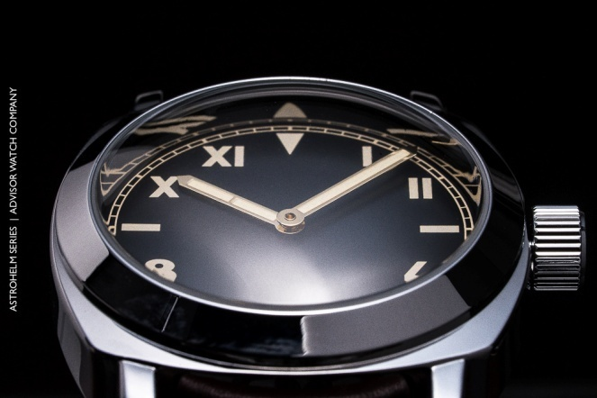 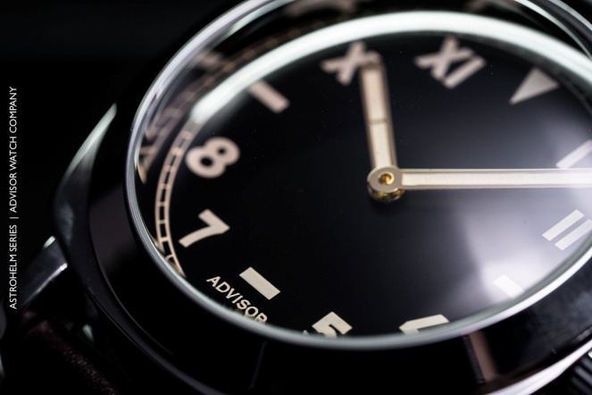

​

The markers and hands are lavishly equipped with luminous colour which mimics the appearance of aged radium.

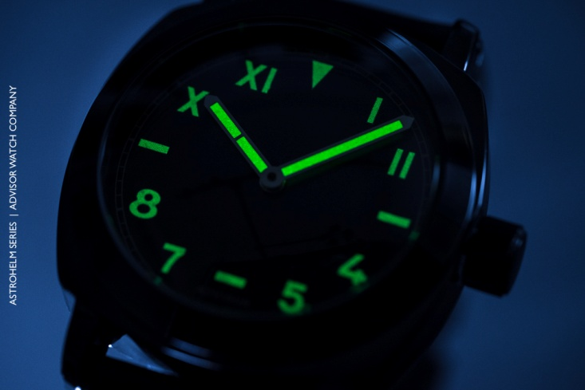

AstroHelm pushes the limit by installing a high double domed glass which resembles an astronaut helmet glass. It beautifully brings out the extreme curve to the watch front and giving it a unique aesthetic look of the timepiece from different angles. History combined with style, the AstroHelm underlining magnificently the vintage character of this watch.

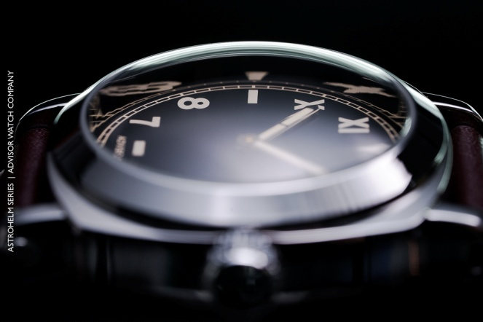 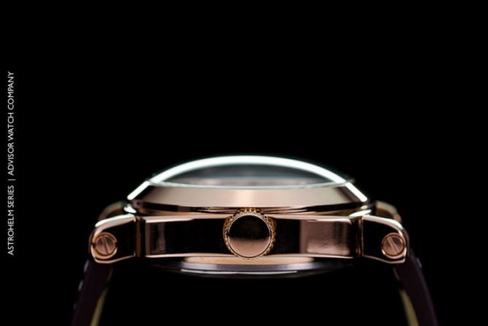

AstroHelm lines up both quartz and automatic limited edition version which caters for different audiences. The special release of automatic version of AstroHelm was added into the campaign based on their supporters’ request and feedback. The key unique feature of the automatic version is in its Brushed Antique Plating Dial, which are not seen on many watches as it require a special processing technique on the dial material which adds on the complexity in producing it.

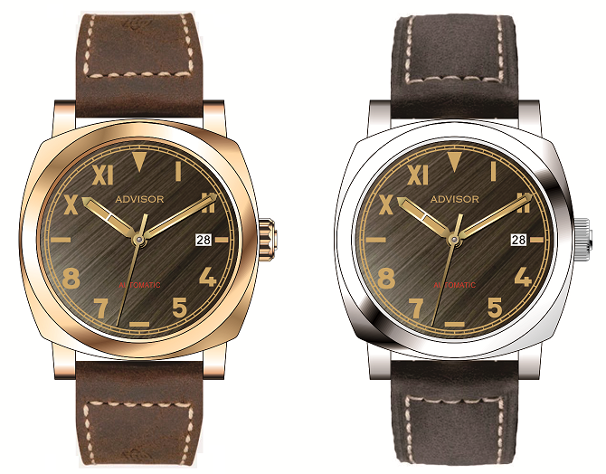

**Limited to 100 Pieces each model**

|  |  |
| --- | --- |
| **Specification** | |
| **AstroHelm Quartz** | **AstroHelm Automatic LE Special Release** |
| * Stainless Steel * Diameter 44.5 mm * Height 16 mm * Lug Width 24 mm * Double Domed Mineral Glass * Japan Miyota Quartz * Water Resistance to 5 ATM * California Dial Vintage * Luminous Vintage "Old Radium" * Hour and Minute with Luminous Vintage "Old Radium" * 24 mm Full Grain Leather Strap | * Stainless Steel * Brushed Antique Plating Dial * Diameter 44 mm * Height 14 mm * Lug Width 24 mm * Double Domed Sapphire Crystal * Japan NH35 Automatic * Date Function * Open Back Case Featuring Movt * Water Resistance 10 ATM * California Dial Vintage * Luminous Vintage "Old Radium" * Hour and Minute with Luminous Vintage "Old Radium" * 24 mm Full Grain Leather Strap |

For more information, please visit:

<https://www.kickstarter.com/projects/1841642015/advisor-astrohelm-watch-tribute-to-history>

**About Advisor**

Advisor Watch Company (AWC) was established with an objective to bring unique and quality timepieces to the market at an affordable price without compromising on the design. It produces watches under brand name of Advisor in small quantity to provide their customers the exclusivity feel and providing them an alternative choice to their daily wrist wear in style. Great men have worn watches for hundreds of years. Wearing a watch is not merely for its function or as an accessory only, but it is a man's reflection and connection to the past, defining his style and who he is.  Who says one need to wear an expensive watch to be in style?

**About the Creator**

Andy Siow, is the brainchild & co-founder of Advisor Watches ([www.advisorwatches.com](http://www.advisorwatches.com)). His watch journey sparks off with an automatic watch he received as a Christmas gift back in 2012. Since then, he has taken his watch collecting hobby to a new level by producing Advisor brand watches. Andy is a firm believer of crowd-sourcing, funding and financing models. He shared “Being a micro-brand start-up, we need to be innovative and creative in how we go to market with our brand at the most cost efficient ways, translating these cost benefits to our customers while delivering great value watches to delight them”.